# CentOS install



Lineblocs open source is a free and fully featured cloud PBX supporting all the functionality of the lineblocs cloud version and having a configuration suitable for those who prefer to run a PBX on their servers.

This tutorial will be going over how to install lineblocs and its minimum requirements on a base CentOS 8 image. We will be going over the installation of asterisk and apache, as well as how to configure the lineblocs web app and backend tools.

By the end of this tutorial, you should have a working lineblocs instance running as a Linux service.

## Getting Started

You will need first to update the centos 8 package manager (yum), install development tools and also disable SELinux. Depending on how you installed centos, this may or may not have already been done.

To update, the package manager and disable SELinux, please use the following steps below:

1. Update yum

yum -y update

1. Install development tools

yum group install "Development Tools"

## Disabling SELinux

1. run command

cat /etc/selinux/config

If you don't see "SELINUX=disabled," please run the following command

sed -i 's/SELINUX=.*/SELINUX=disabled/' /etc/selinux/config

Followed by a system reboot

reboot

## Installing Lineblocs

Below, we will go over how to install the base dependencies for lineblocs and then how you can run the lineblocs web installer to set up the database and configure lineblocs to work with apache and asterisk.

Lineblocs requires some dependencies to work. You will need to at the least install Apache 2.4, PHP 7 as well as Asterisk 16 and its dependencies. We will be installing and configuring Apache and PHP first, followed by installing the base of asterisk and then setting up the networking and folder privileges required to make lineblocs run correctly.

To install Apache and PHP you please use the following commands:

1. Install Apache HTTPD

yum install httpd

1. Install PHP 7

We will be using the remi CentOS repo to install the recommended version of PHP (7.3) on our Linux instantly. To install PHP 7.3 on the CentOS please use the following steps:

sudo dnf -y update

sudo dnf -y install https://dl.fedoraproject.org/pub/epel/epel-release-latest-8.noarch.rpm

sudo yum -y install http://rpms.remirepo.net/enterprise/remi-release-8.rpm

sudo dnf -y install dnf-plugins-core

sudo dnf config-manager --set-enabled remi-php73

sudo dnf config-manager --set-enabled remi

sudo dnf module install php:remi-7.3

sudo dnf update

1. Download and unzip lineblocs code in "/var/www/html"

cd /var/www/html

wget

http://get.lineblocs.com/lineblocs-0.0.1.zip

unzip lineblocs-0.0.1.zip

1. Installing lineblocs base

cd lineblocs

./install_base.sh

# Configuring MySQL

During the base installation you will need to set up MySQL. Please make sure you leave the password blank and remove all remote logins, as well as reload all privilege tables.

Enter current password for root (enter for none):

Do not enter anything here

Change the root password? [Y/n]

Press "n" to this

Remove anonymous users? [Y/n]

Press "Y" here

Disallow root login remotely? [Y/n]

Press "Y" here

Remove test database and access to it? [Y/n]

Press "Y" here

Reload privilege tables now? [Y/n]

Press "Y" here

Once the mariadb installation completes, you will see some other dependencies being installed. Be sure to let the installer run and install all the other dependencies. The asterisk configuration and installation should take 3-5 minutes to complete.

The installer will show the asterisk menu; select options once the asterisk has been successfully configured. Please select the default settings here and then use "Save & Exit".

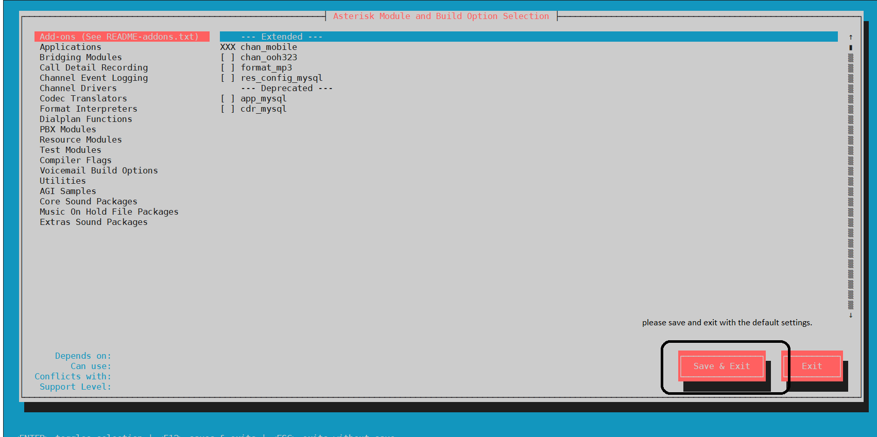

You should then see an asterisk continuing to build for some time, followed by the installation script changing the folder permissions and networking setup according to lineblocs requirements.

Once all of this is completed; you should get a confirmation that the lineblocs base installation was completed successfully.

You can then continue to install lineblocs using the web installer.

## Running the web Installer

The lineblocs web installer includes steps that help you configure the database and asterisk for usage with lineblocs. When you downloaded the lineblocs code, the installer will automatically download. To run the web installer, please use the following command:

./start_web_installer.sh

You will be then given an address to use in your browser. Please go to the URL in your browser to complete the web installation.

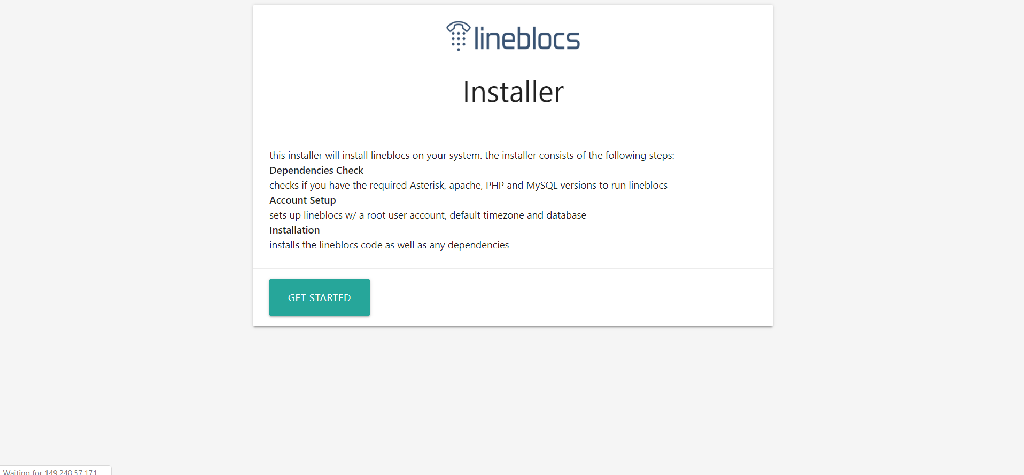

### Step 1 - Requirements check

Lineblocs installer will try to check if the requirements for lineblocs are met. You should have a screen as shown below. All the requirements will need to match for lineblocs to be installed correctly.

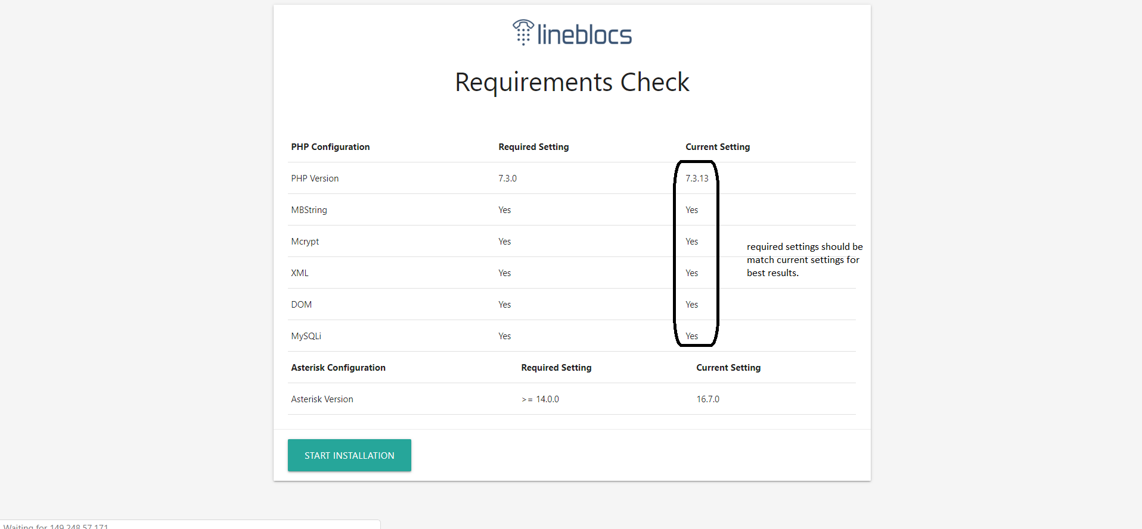

If the all requirements are provided, please click "Start Installation."

### Step 2 - Database configuration

You will need to set up a database for lineblocs to work correctly. At this point in the tutorial, we have already installed mariadb server and set up the root account with no password. You can use the root account to create a new database called "lineblocs" with a username/password of your choice. The new database user will be assigned to the lineblocs database and also used in the lineblocs backend.

Below is an example of how you might want to set up the database.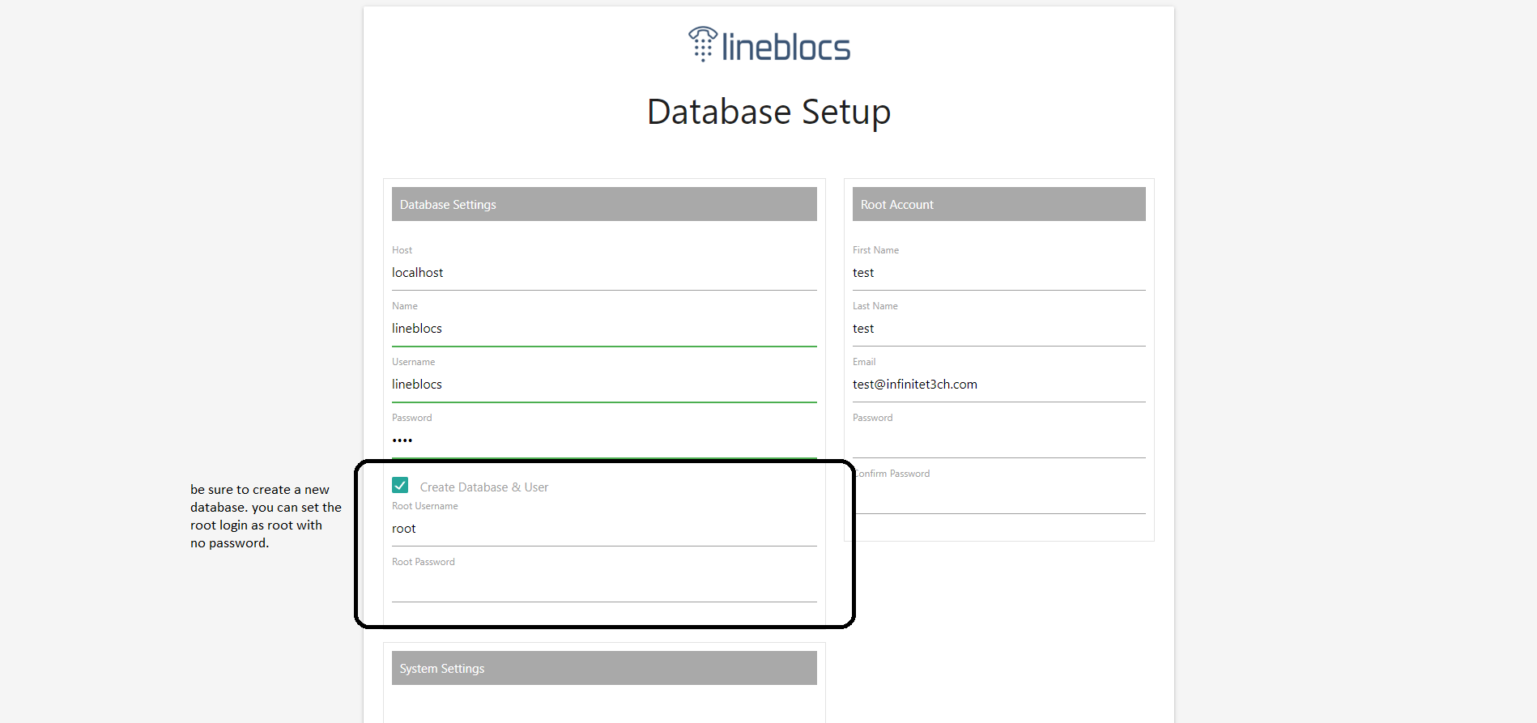

#### root account configuration

This sets up the main admin account you will use to log in to the Lineblocs portal. This is also the main account or the "super" admin account that has all permissions in the system. 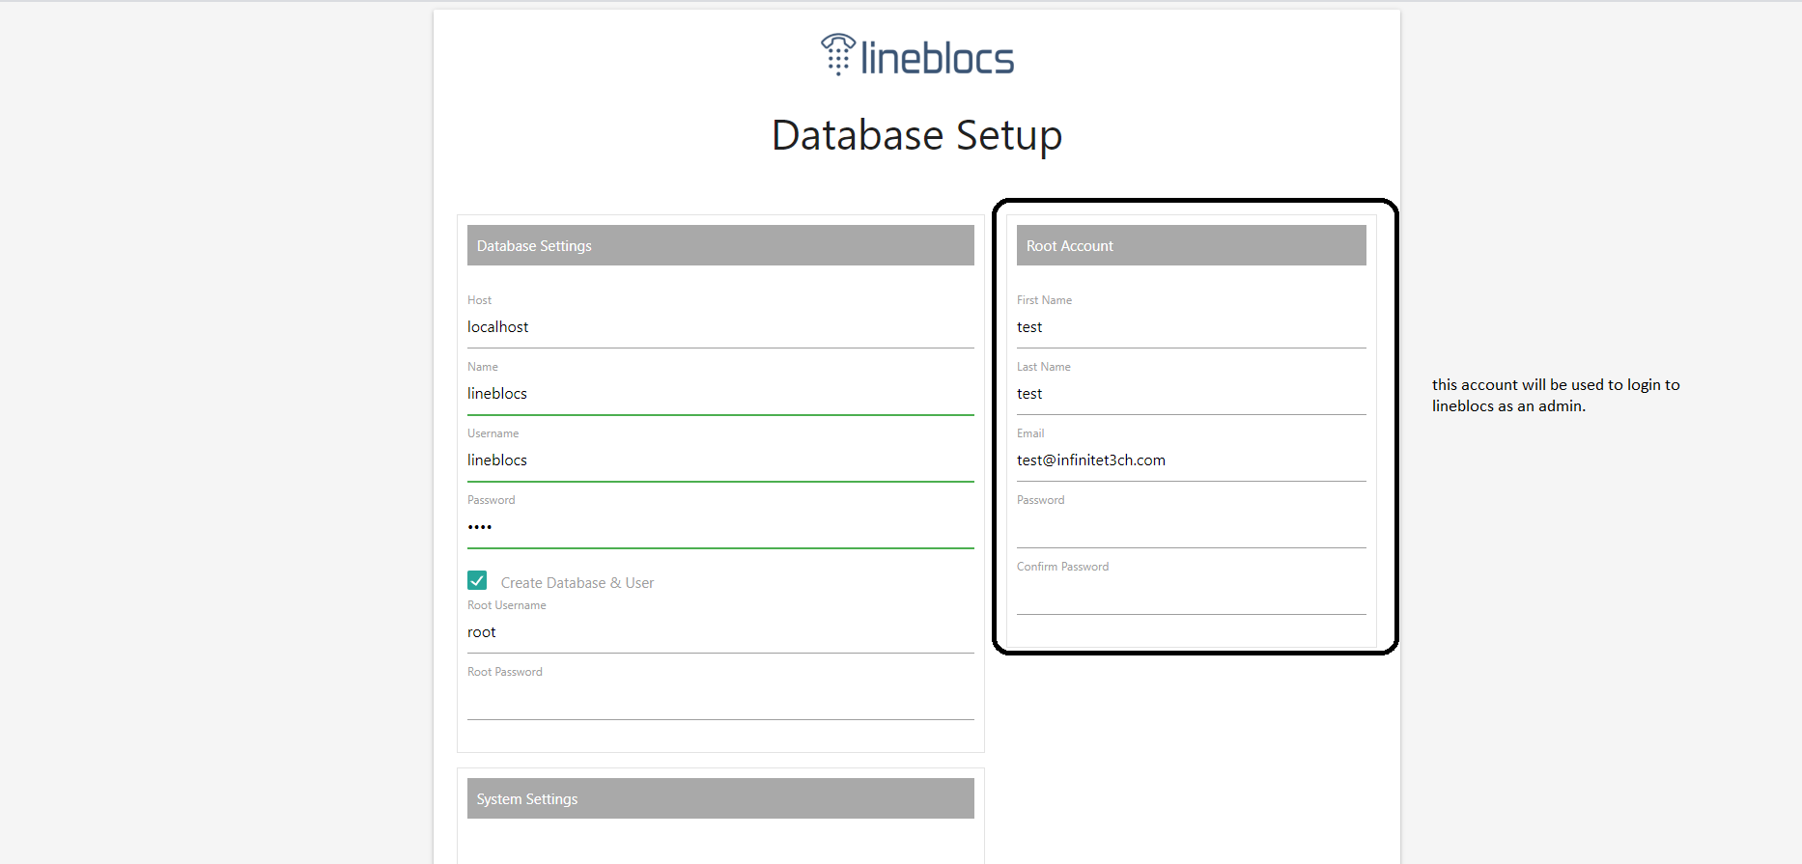

### Step 3 - Config Setup

Some steps will be required to update the asterisk and Apache config to work with laravel. Please follow the steps below to complete Asterisk/Apache setup. 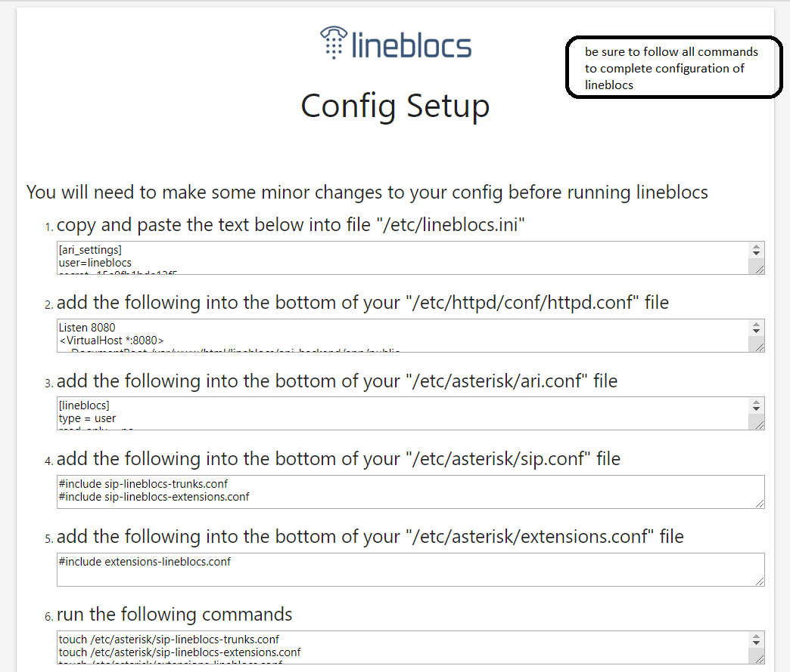

### Step 4 - Install as Linux service

To run the lineblocs backend, you will need to install lineblocs as a Linux service. Please continue to follow the steps as they are listed below. 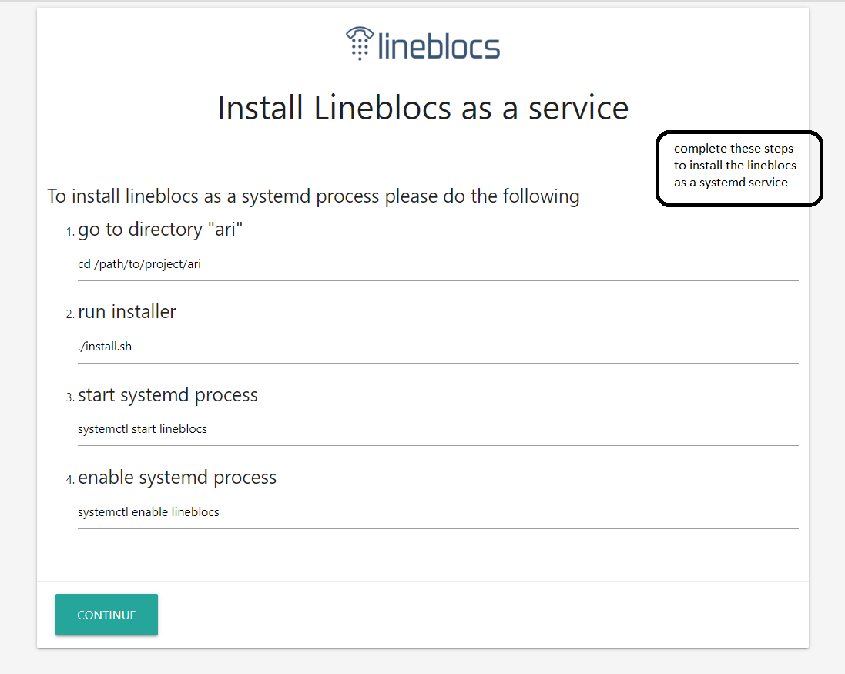

Once you have done this, lineblocs should be installed and enabled as a system process.

If you are having issues, you can verify lineblocs is running on the linux instance by using the command below:

ps aux | grep 'lineblocs'

You should see output similar to the following:

root 18665 0.0 5.4 1051036 46128 ? Ssl 06:45 0:00 /usr/sbin/lineblocs

If you don't see this output, you can check the combined.log and error.log of lineblocs in "/var/log/lineblocs"

cat /var/log/lineblocs/error.log

This file should include any helpful info for debugging the problem.

You can also re-run the web installer by using the shell script included in the lineblocs. distribution prune_installer_data.sh followed by running start_web_installer.sh again

./prune_installer_data.sh

./start_web_installer.sh

### Step 5 - Completing the installation

Once the installation and configuration are done, you should be shown a message, as seen below. 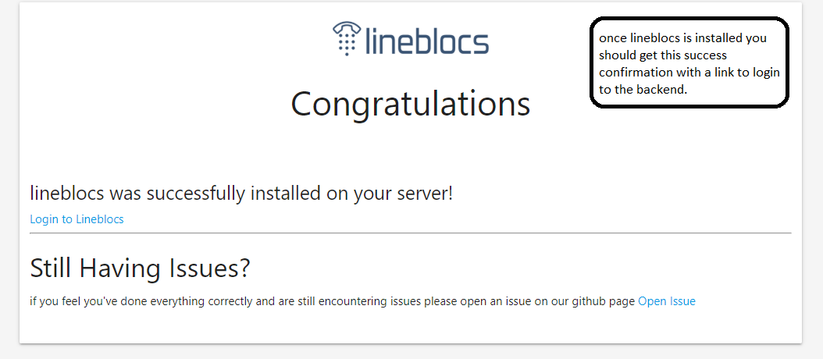

## Logging in the first time

Be sure to follow the login link given in step 5 to login to lineblocs. You will need to use the account login you set up as the super admin to log in. 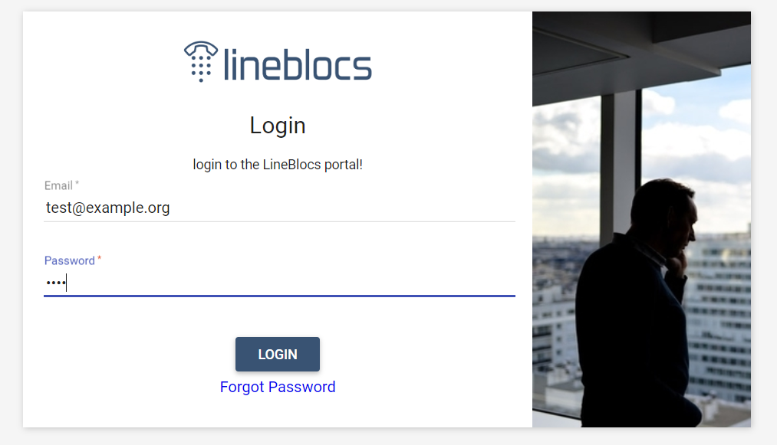

## Next Steps

This tutorial went over how to install lineblocs open source edition. For related articles, be sure to check out the following:

[Creating Trunks](https://lineblocs.com/resources/open-source/creating-trunks)

[Working with routes](https://lineblocs.com/resources/open-source/working-with-routes)

[Setup Open Source Extension](https://lineblocs.com/resources/open-source/setup-extension)